ARMG Gantry Anticollision Sensor Replacement
Replacement of existing sick laser (LMS 511) with Sick Visionary B Two sensor (3D machine vision)
(*check the properties of the new device if neede in the attached manual)
Why?
- intermittent triggering device fault
- 2D scanning range which results in blind spots
- Goal: 2 in 1 solution: more stable detection and camera view
Observations:
- More flexible mounting and alignment configuration
- More flexible field configuration in 3D
Current deployment (testing phase): ARMG E303, Landside gantry legs 1 & 2
Field configuration:
Field | Distance from Device | PLC Parameter
Stop | 6m | Laser1Stop
Slow Down | 13m | Laser1SlowDown
Contamination | 1m | Laser1Fault

Case #1: Stop Field Activated
Field View
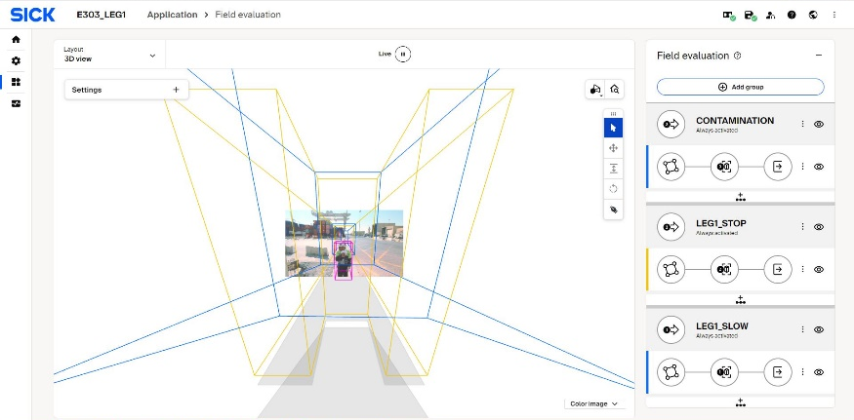
Video Livestream View
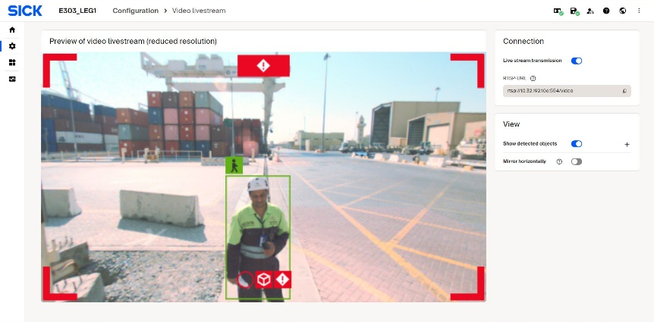

Disk View:
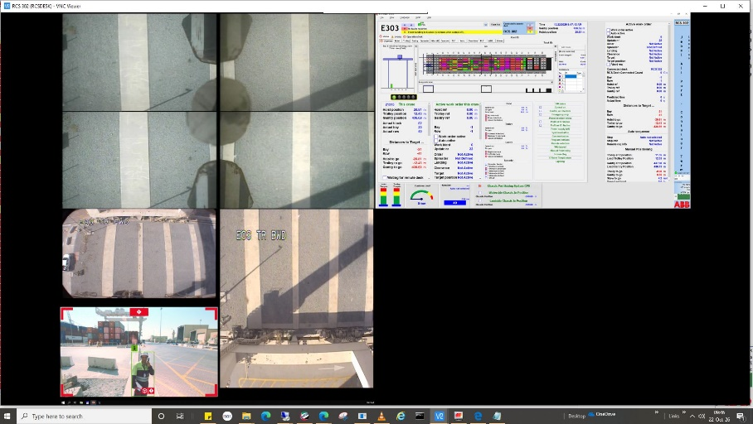

Case #2: Slow Down Field Activated
Field View
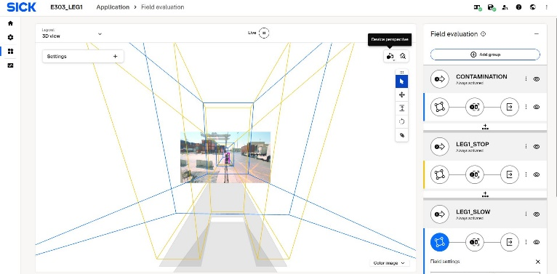

Video Livestream View
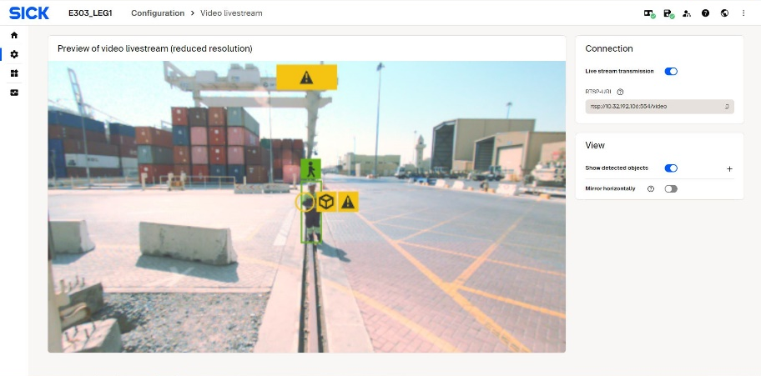

Disk View:
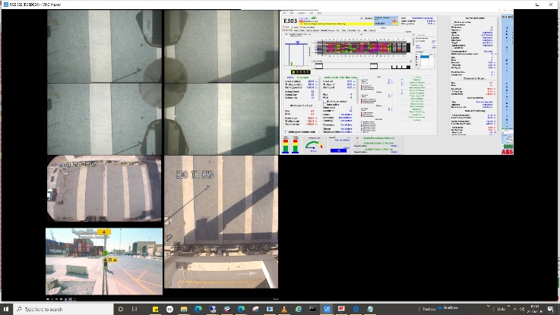

Case #3: Contamination Activated
Field View
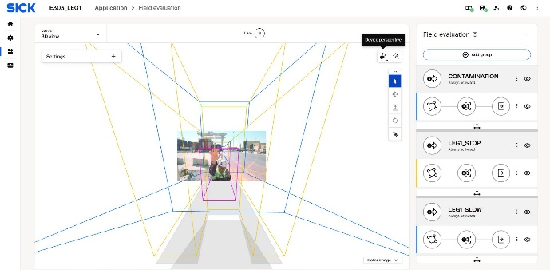
Video Livestream View
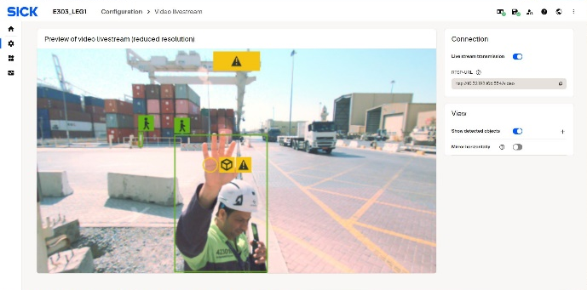
Disk View:
